# Project Development Phase

# Model Performance Test

|  |  |
| --- | --- |
| DATE | 18 NOVEMBER 2022 |
| TEAM ID | PNT2022TMID37936 |
| PROJECT NAME | DIGITAL NATURALIST – AI ENABLED TOOL FOR BIODIVERSITY RESEARCHERS |
| MAXIMUM MARKS | 10 MARKS |
| TEAM LEADER | V.VAARANI DEVI |
| TEAM MEMBERS | G.PAVITHRA,J.TAMILARASI,J.VENNILA,P.THANGA PUSHPA |

**Model Performance Testing:**

Project team shall fill the following information in model performance testing template.

|  |  |  |  |
| --- | --- | --- | --- |
| **S.No.** | **Parameter** | **Values** | **Screenshot** |
| 1. | Model Summary | Total params: 22,109,990  Trainable params: 307,206  Non-trainable params: 21,802,784 | Screenshot 1 |
| 2. | Accuracy | Training Accuracy - 90.9%    Validation Accuracy - 96.3% | Screenshot 2 |

Screenshots - Please refer to the next page:

**Screenshot 1 :**

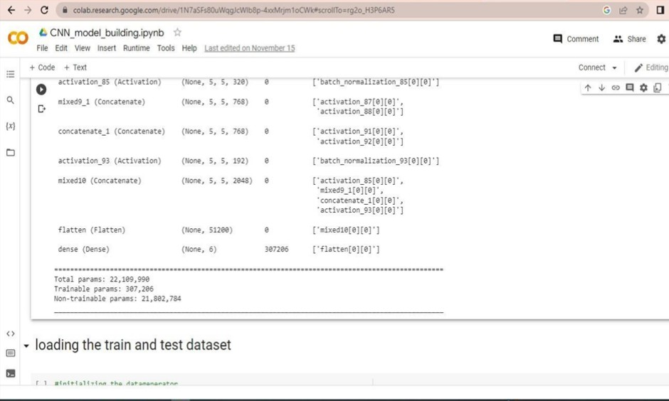

**Screenshot 2:**

